Installing GNS3

Section 13, Lecture 73

**Step 1:**

Go to https://www.gns3.com and download the appropriate installation file for your operating system (Windows, Macintosh, or Linux).

**Step 2:**

Using the installer, install GNS3. If you are using a Mac, you will simply open the DMG, then drag the GNS3 file to the Application directory.

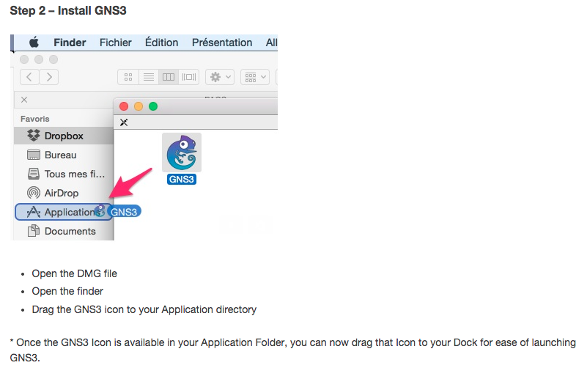

**Step 3:**

GNS3 is used in a lab environment for testing and education. Once you have obtained your own copy of a Cisco IOS for one of the supported platforms, you are ready to continue. Cisco 7200, 3600 series, 3700 series, and 2600 series are supported by GNS3.

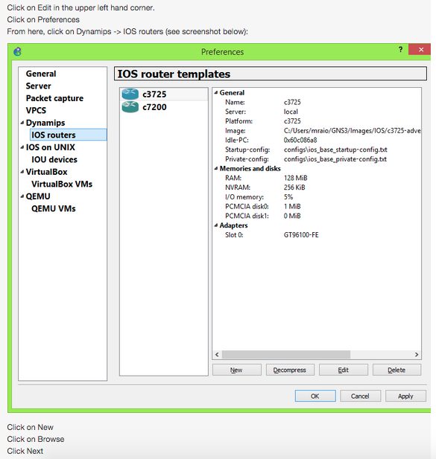

The next screen shows that GNS3 detected the router platform, and named it according to the platform.

Here is where you will configure your modules. Cisco devices are modular, meaning that you can add modules based on the type of network you want.

Finally, you can set the IDLE PC setting. I recommend leaving it set at the default. You will now be given a status page summarizing the options selected in the IOS routers preferences.

Hit APPLY in the lower right corner, the OKAY. Now, click the Router icon again.

You will see that you now have an available router. Drag and drop this router into the main panel which is where you will configure your network topology.

You now need to start the router by either right clicking on the router and selecting start, or clicking on the right pointing start arrow located in the header area. This will start all devices selected and configured to allow a startup.

Now, it is time to create our first virtual network.